Polygon–Circular–Freeform Open Shapes
# Source: AI Source: Provided by: [Data Path: Persons Table -> ID Column: 1, Name_En Column: Motasem Essam] -> From: [ChatGPT] on [7/25/2026]
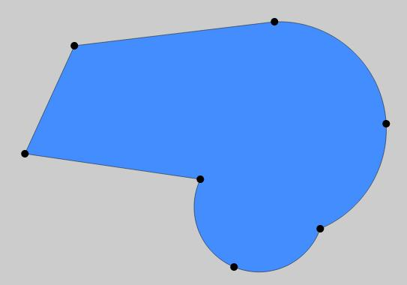
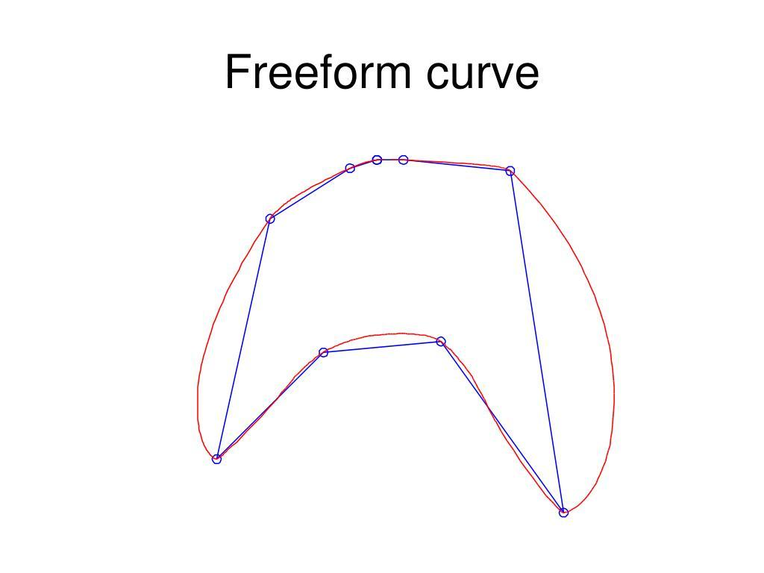
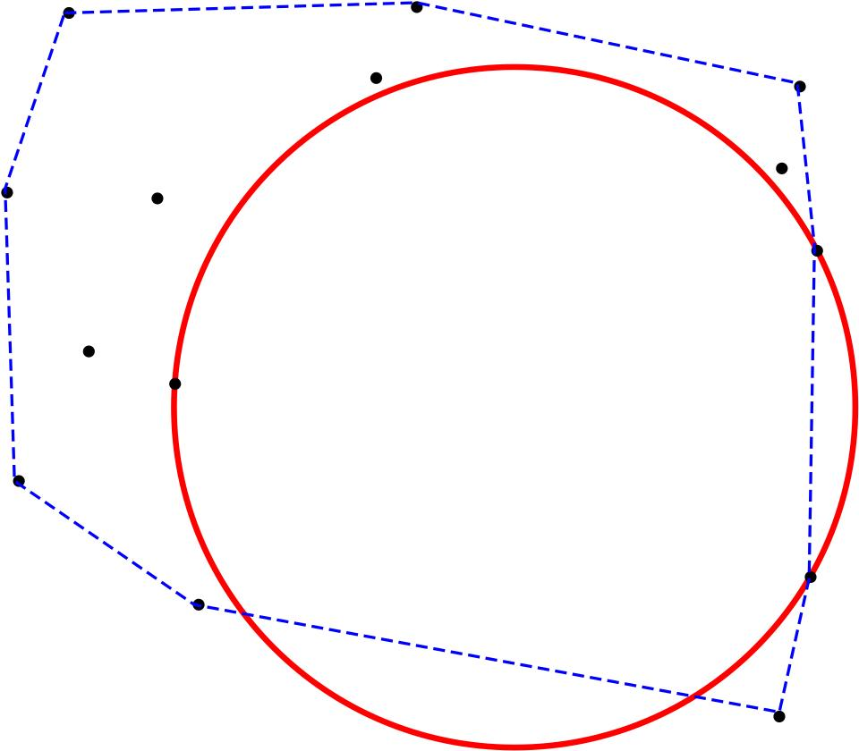
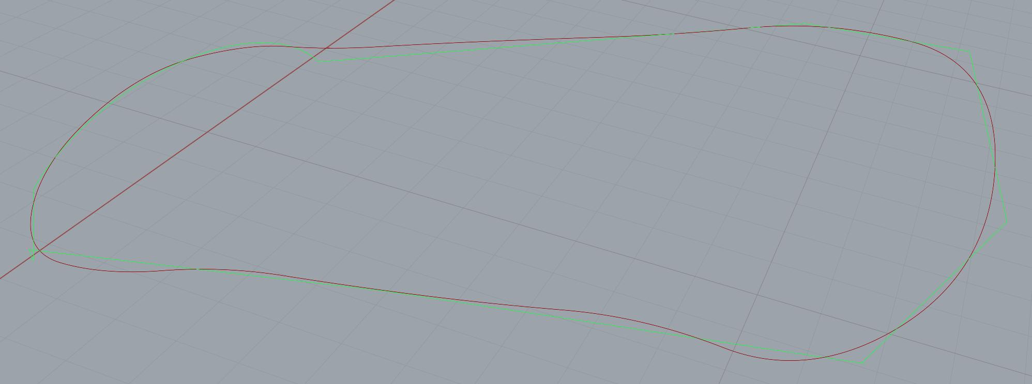

Definition
# Source: AI Source: Provided by: [Data Path: Persons Table -> ID Column: 1, Name_En Column: Motasem Essam] -> From: [ChatGPT] on [7/25/2026]
A Polygon–Circular–Freeform Open Shape is an open mixed shape that combines three different geometric components:
- Polygonal straight segments
- Circular arc(s)
- Freeform curved portion(s)
$$\boxed{\text{Polygon–Circular–Freeform Open Shape}=\text{Polygonal Segments}+\text{Circular Arc(s)}+\text{Freeform Curve(s)}+\text{Open Boundary}}$$
The shape remains open because its path does not completely return to its starting point.

Characteristics
# Source: AI Source: Provided by: [Data Path: Persons Table -> ID Column: 1, Name_En Column: Motasem Essam] -> From: [ChatGPT] on [7/25/2026]
A Polygon–Circular–Freeform Open Shape:
- Is open.
- Contains at least one straight polygonal segment.
- Contains at least one circular arc.
- Contains at least one freeform portion.
- Combines straight, circular, and freely designed geometry.
- Has at least two endpoints.
- May have sharp corners.
- May have smooth or tangential transitions.
- Does not enclose an area by itself.
- Can be regular-looking, irregular, symmetric, or asymmetric.

Types of Polygon–Circular–Freeform Open Shapes

1. Simple Polygon–Circular–Freeform Open Shape
# Source: AI Source: Provided by: [Data Path: Persons Table -> ID Column: 1, Name_En Column: Motasem Essam] -> From: [ChatGPT] on [7/25/2026]
A basic open path containing a few polygonal segments, one circular arc, and one freeform curve.
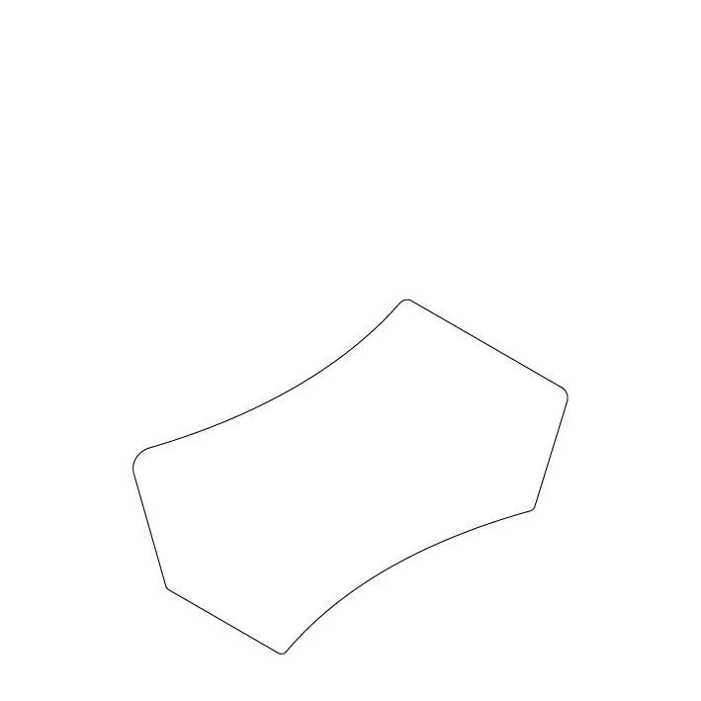
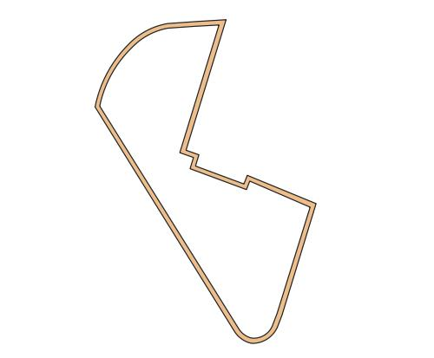

2. Single-Arc Polygon–Circular–Freeform Open Shape
# Source: AI Source: Provided by: [Data Path: Persons Table -> ID Column: 1, Name_En Column: Motasem Essam] -> From: [ChatGPT] on [7/25/2026]
An open path containing one circular arc, polygonal segments, and a freeform curve.
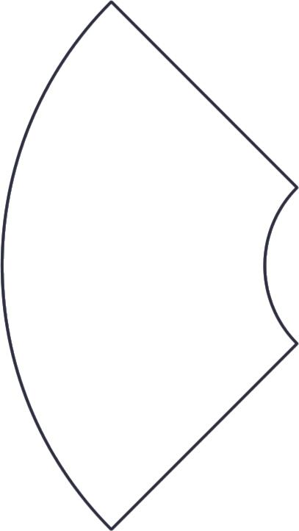
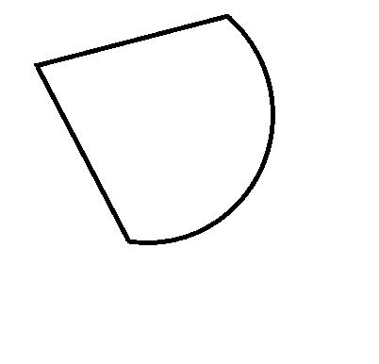
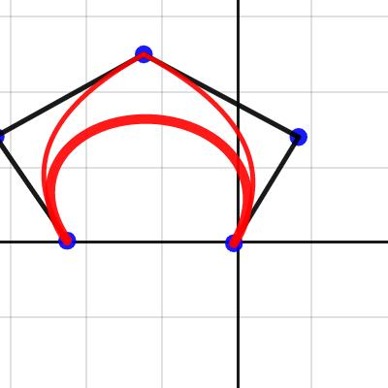

3. Multi-Arc Polygon–Circular–Freeform Open Shape
# Source: AI Source: Provided by: [Data Path: Persons Table -> ID Column: 1, Name_En Column: Motasem Essam] -> From: [ChatGPT] on [7/25/2026]
An open path containing multiple circular arcs together with polygonal and freeform sections.
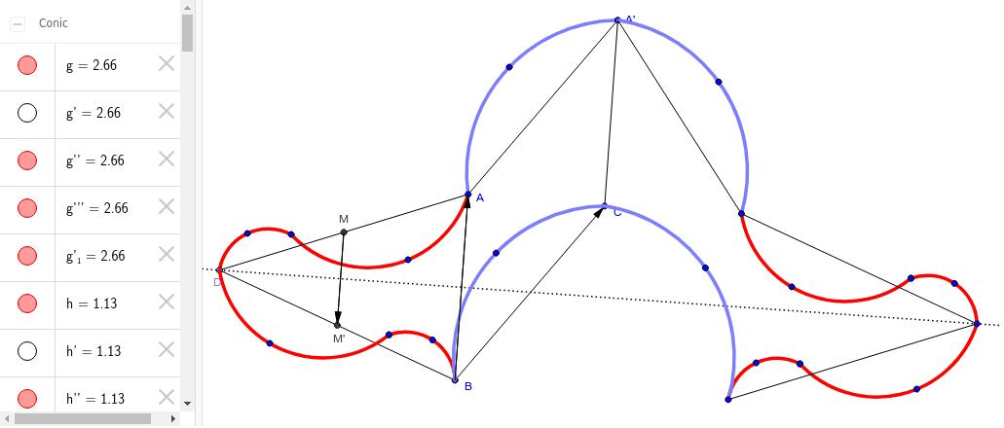
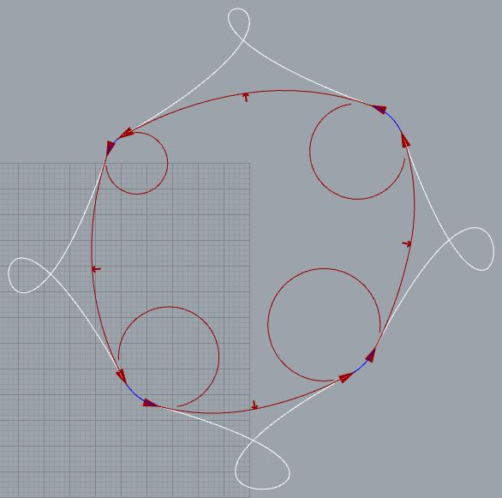

4. Smooth Polygon–Circular–Freeform Open Shape
# Source: AI Source: Provided by: [Data Path: Persons Table -> ID Column: 1, Name_En Column: Motasem Essam] -> From: [ChatGPT] on [7/25/2026]
The polygonal segments, circular arcs, and freeform curves connect with relatively smooth transitions.
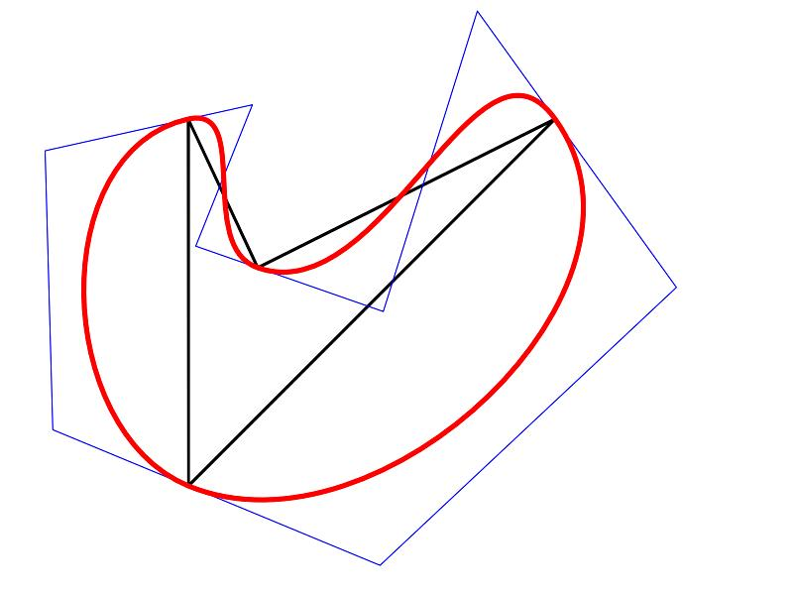
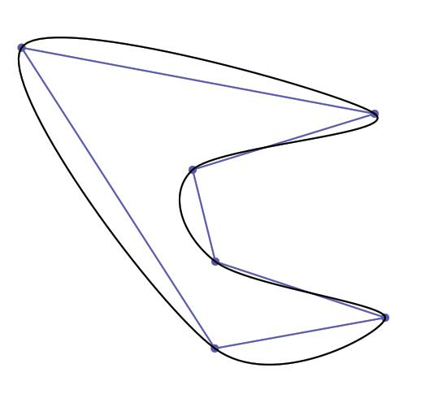

5. Cornered Polygon–Circular–Freeform Open Shape
# Source: AI Source: Provided by: [Data Path: Persons Table -> ID Column: 1, Name_En Column: Motasem Essam] -> From: [ChatGPT] on [7/25/2026]
The three components meet at visible corners or abrupt changes in direction.
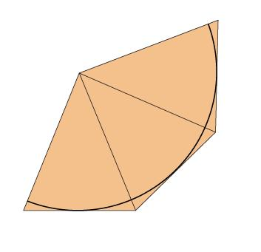

6. Symmetric Polygon–Circular–Freeform Open Shape
# Source: AI Source: Provided by: [Data Path: Persons Table -> ID Column: 1, Name_En Column: Motasem Essam] -> From: [ChatGPT] on [7/25/2026]
The overall arrangement has a recognizable axis of symmetry even though the freeform portion is not a standard curve.
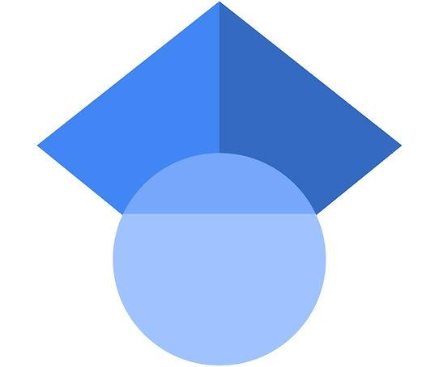

7. Asymmetric Polygon–Circular–Freeform Open Shape
# Source: AI Source: Provided by: [Data Path: Persons Table -> ID Column: 1, Name_En Column: Motasem Essam] -> From: [ChatGPT] on [7/25/2026]
The polygonal, circular, and freeform portions have different sizes, positions, or curvature.
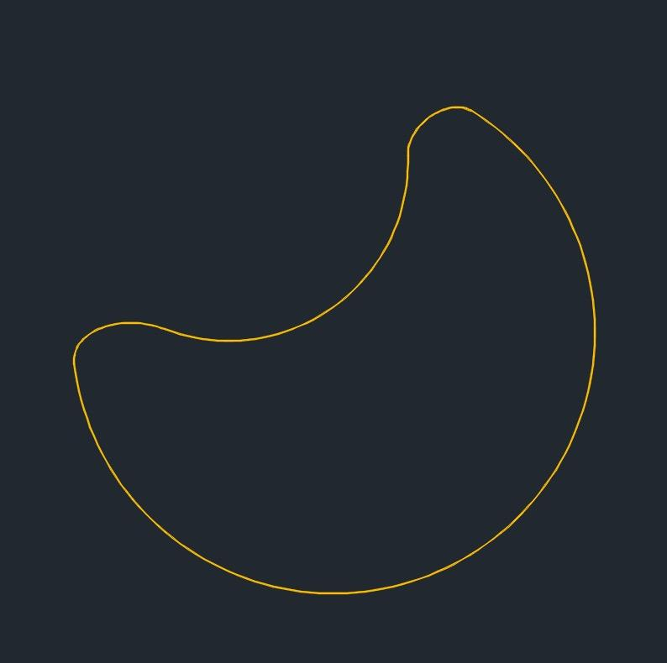

8. Wavy Polygon–Circular–Freeform Open Shape
# Source: AI Source: Provided by: [Data Path: Persons Table -> ID Column: 1, Name_En Column: Motasem Essam] -> From: [ChatGPT] on [7/25/2026]
The freeform portion contains irregular waves or undulations in addition to the polygonal and circular sections.
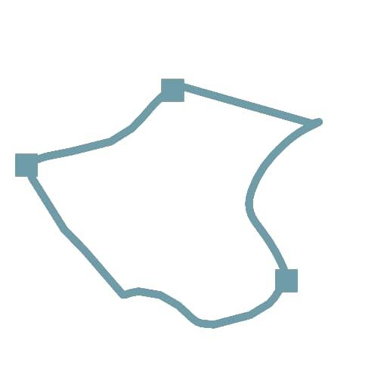
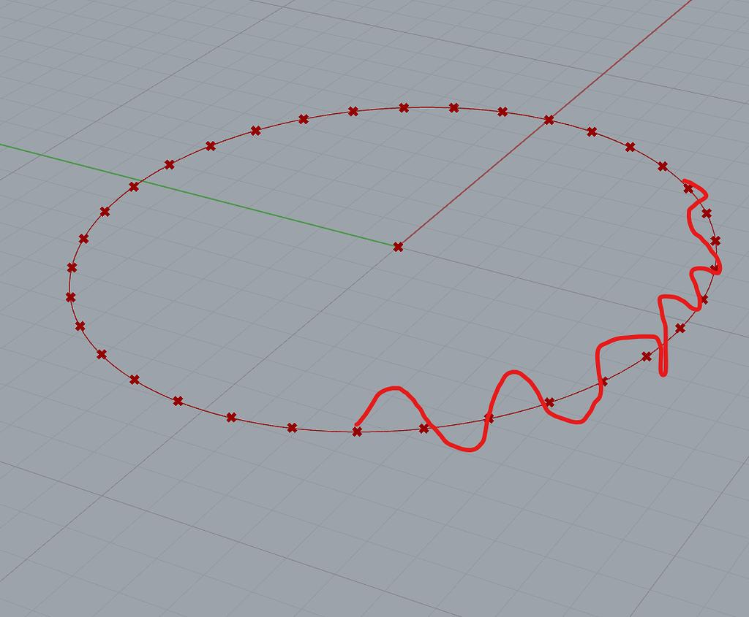
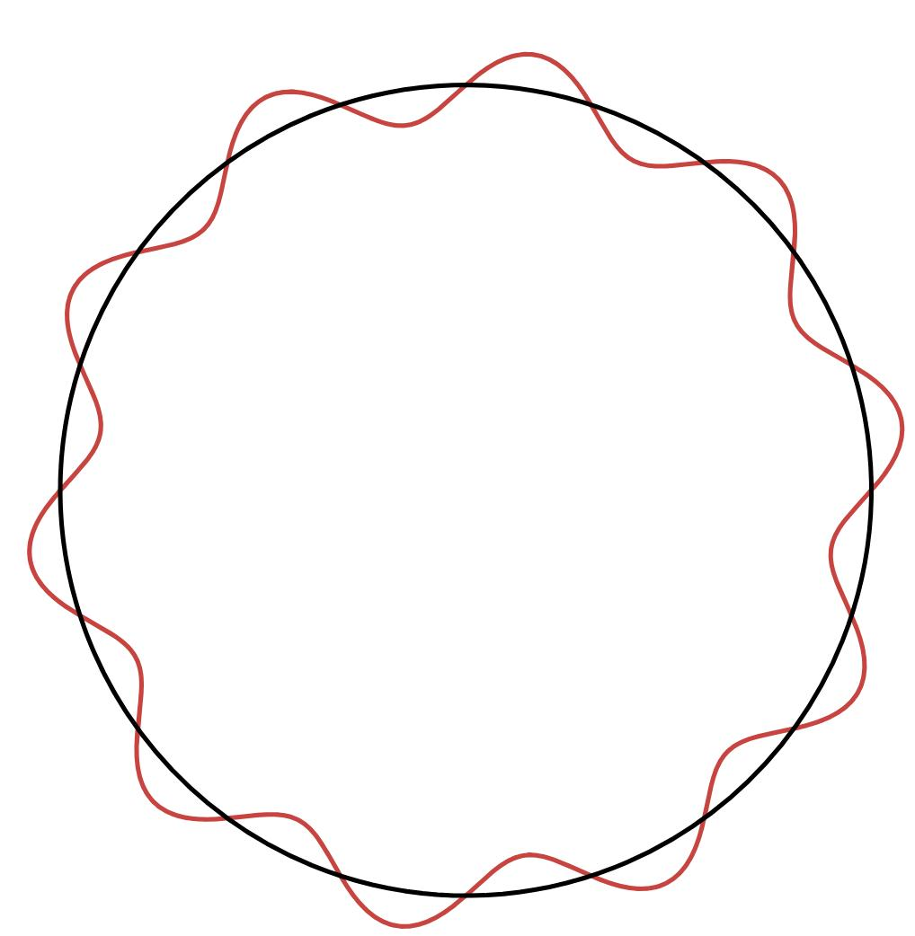

9. Tangential Polygon–Circular–Freeform Open Shape
# Source: AI Source: Provided by: [Data Path: Persons Table -> ID Column: 1, Name_En Column: Motasem Essam] -> From: [ChatGPT] on [7/25/2026]
At least one circular arc and a freeform curve connect smoothly with a common tangent direction, while polygonal segments form another part of the path.
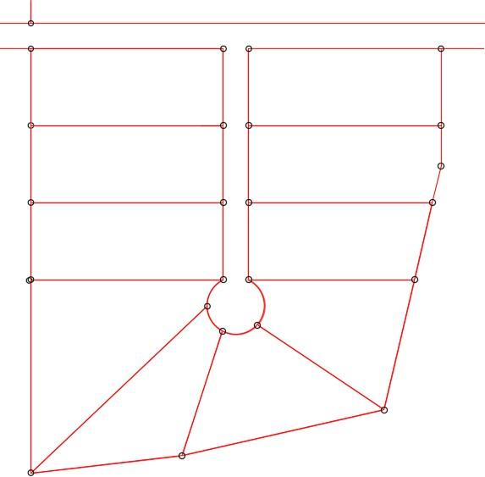
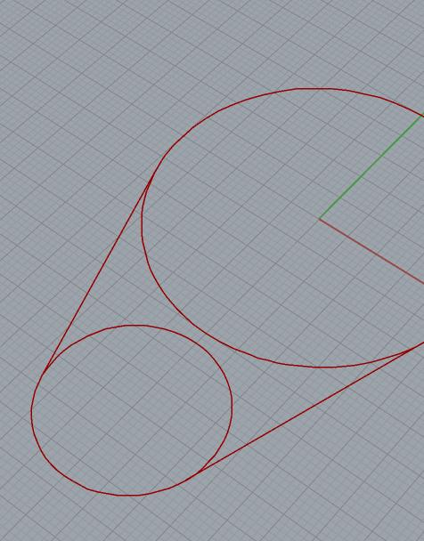
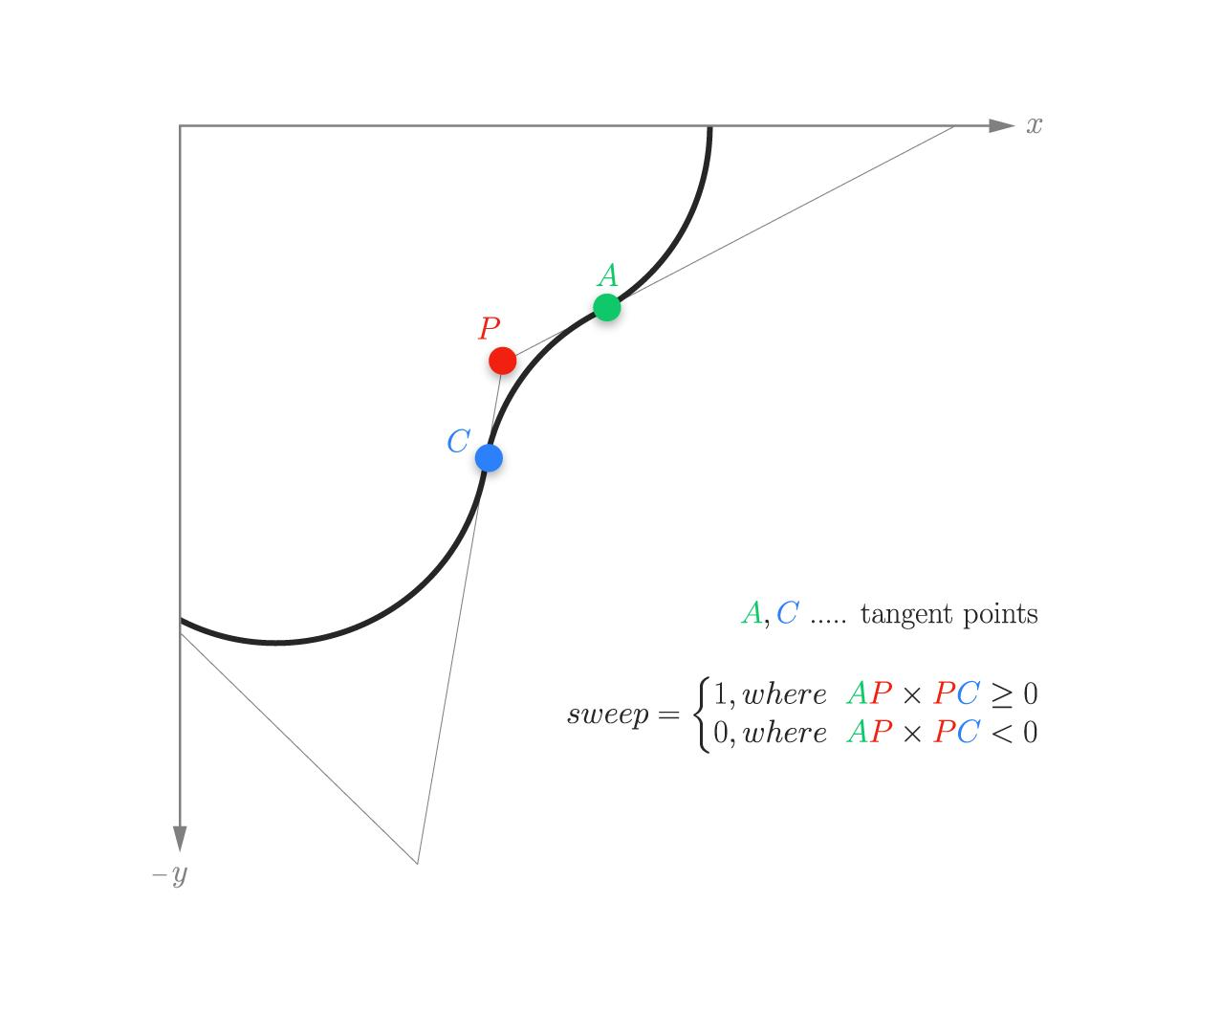

10. Irregular Polygon–Circular–Freeform Open Shape
# Source: AI Source: Provided by: [Data Path: Persons Table -> ID Column: 1, Name_En Column: Motasem Essam] -> From: [ChatGPT] on [7/25/2026]
All three components vary irregularly in their lengths, angles, radii, and curvature.
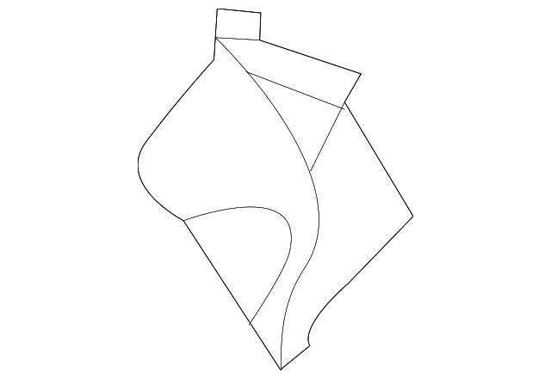
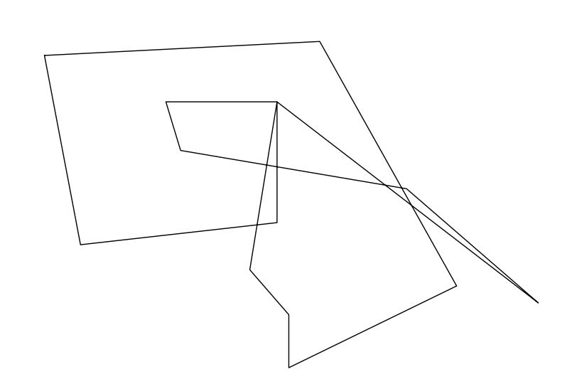

11. Multi-Bend Polygon–Circular–Freeform Open Shape
# Source: AI Source: Provided by: [Data Path: Persons Table -> ID Column: 1, Name_En Column: Motasem Essam] -> From: [ChatGPT] on [7/25/2026]
The path changes direction several times through polygonal corners, circular arcs, and freeform curves.
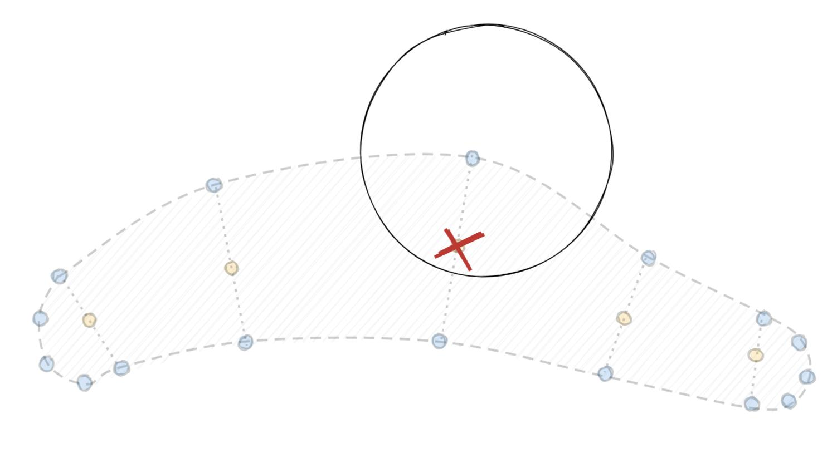
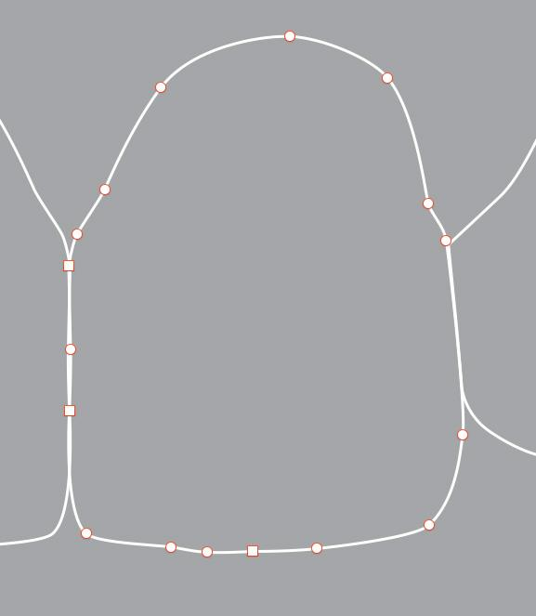

12. Artistic Polygon–Circular–Freeform Open Shape
# Source: AI Source: Provided by: [Data Path: Persons Table -> ID Column: 1, Name_En Column: Motasem Essam] -> From: [ChatGPT] on [7/25/2026]
A deliberately designed open path combining polygonal segments, circular arcs, and artistic freeform curves.

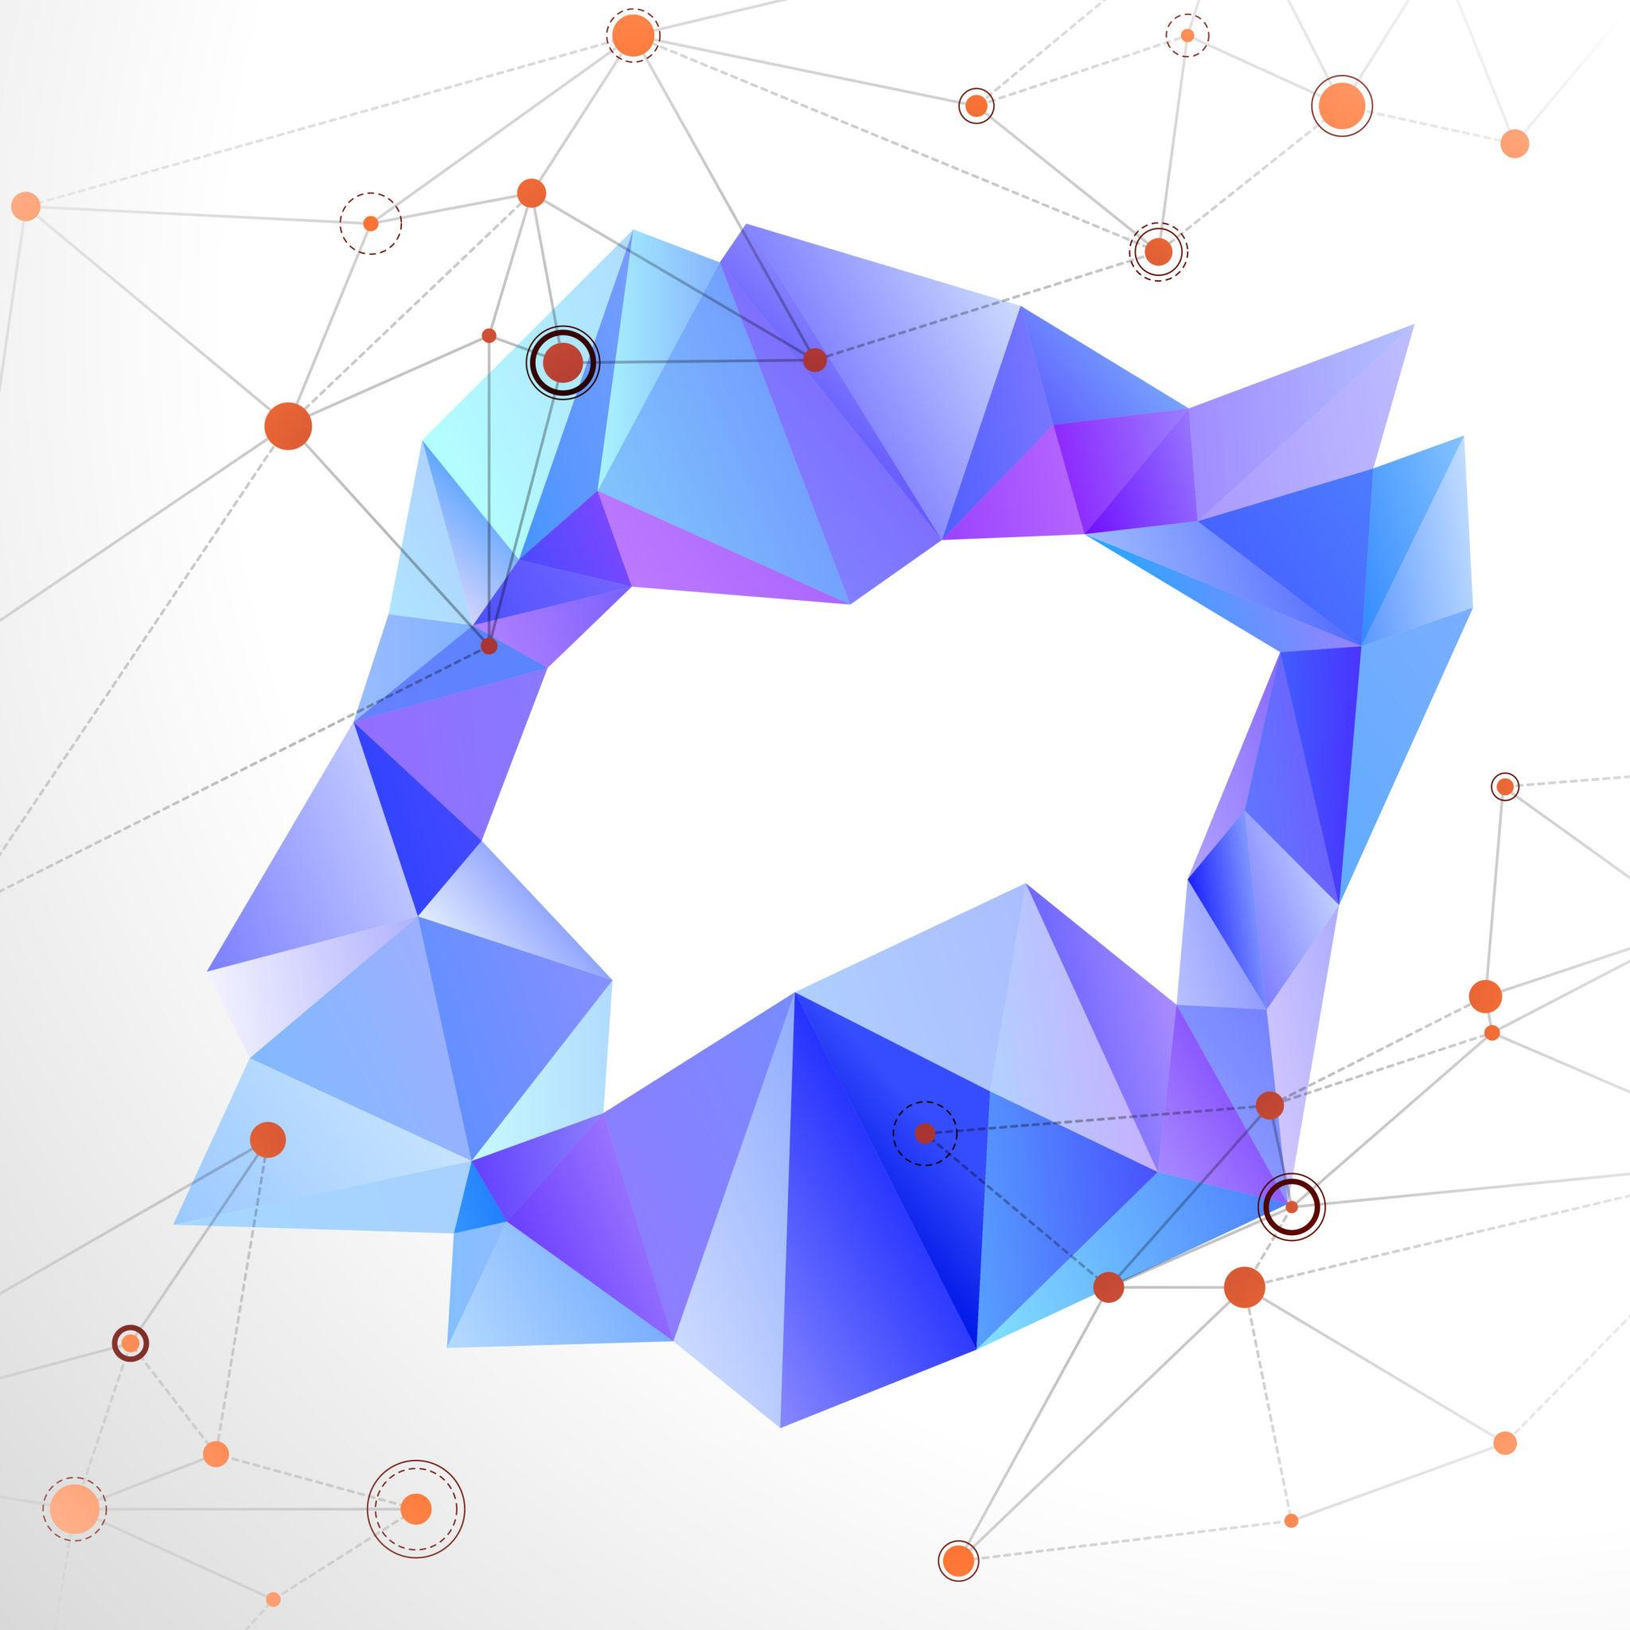


Comparison with Other Open Mixed Shapes
# Source: AI Source: Provided by: [Data Path: Persons Table -> ID Column: 1, Name_En Column: Motasem Essam] -> From: [ChatGPT] on [7/25/2026]
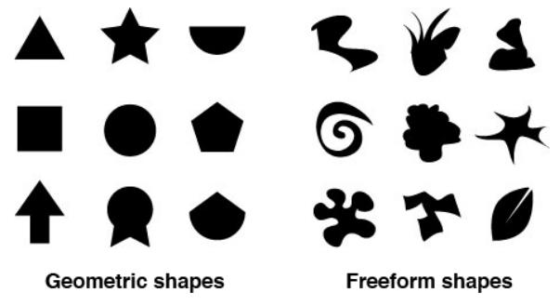
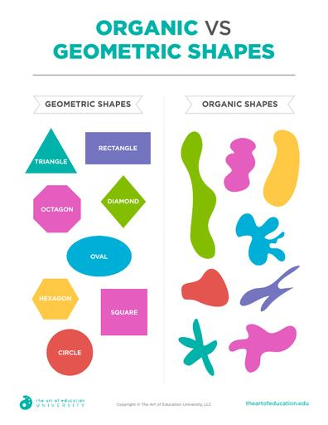
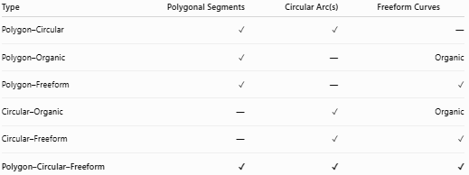
Type | Polygonal Segments | Circular Arc(s) | Freeform Curves
Polygon–Circular | ✓ | ✓ | —
Polygon–Organic | ✓ | — | Organic
Polygon–Freeform | ✓ | — | ✓
Circular–Organic | — | ✓ | Organic
Circular–Freeform | — | ✓ | ✓
Polygon–Circular–Freeform | ✓ | ✓ | ✓
Main distinction
$$\boxed{\text{Polygon–Circular–Freeform}=\text{Polygonal}+\text{Circular}+\text{Freeform}}$$
This makes it a three-component mixed shape, rather than a two-component mixed shape.

Key Points
# Source: AI Source: Provided by: [Data Path: Persons Table -> ID Column: 1, Name_En Column: Motasem Essam] -> From: [ChatGPT] on [7/25/2026]
A Polygon–Circular–Freeform Open Shape is:
$$\boxed{\text{Open}+\text{Polygonal}+\text{Circular}+\text{Freeform}}$$
It must contain:
- Straight polygonal segment(s)
- At least one circular arc
- At least one freeform portion
- At least two endpoints
- An open overall path
The key distinction is that Polygon–Circular–Freeform Open Shapes contain all three components simultaneously, making them more complex than the corresponding two-component categories.

Conclusion
# Source: AI Source: Provided by: [Data Path: Persons Table -> ID Column: 1, Name_En Column: Motasem Essam] -> From: [ChatGPT] on [7/25/2026]
Polygon–Circular–Freeform Open Shapes are complex open mixed shapes that combine three distinct geometric components: polygonal straight segments, circular arcs, and freely designed curved portions.
Their defining structure is:
$$\boxed{\text{Polygonal Segments}+\text{Circular Arc(s)}+\text{Freeform Curve(s)}+\text{Open Boundary}}$$
Unlike simpler mixed shapes, this category contains all three components simultaneously. The polygonal portions provide straight-sided structure, the circular portions provide regular constant-radius curvature, and the freeform portions allow arbitrary or artistic curvature.

